Name- Kaveri Avinash Jarhad

Q1. Navigate to the Scripts directory using an absolute path.

Q2. You are in /home/. Navigate to the Projects directory using a relative path.

Q3. Your current directory is:
/home//Documents/Linux/Notes
Navigate to the Downloads directory using a relative path only.

Q4. Your current directory is:
/home//Documents/Linux/Scripts
Go back to your home directory using the shortest possible command.

Q5. Your current directory is: /home//Documents/Projects Navigate to the Notes directory using a relative path.

Q6. Display your current working directory after navigating to the Pictures directory. Expected Commands cd /home//Pictures pwd
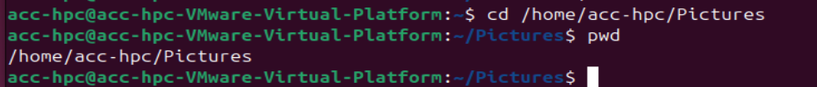

Q7. You are in: /home//Documents/Linux Move to the root directory and verify your location.
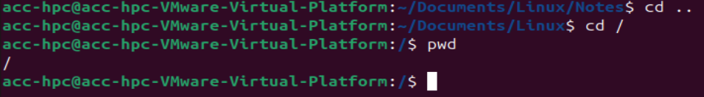

Q8. Without changing your current directory, list the contents of the Downloads directory using an absolute path. (Current directory:) /home//Documents/Linux

Q9. Your current directory is: /home//Documents/Linux/Notes Navigate to the Music directory using a relative path.

Q10. Starting from: /home/ Complete the following sequence:
1. Go to Documents/Linux
2. Move to its parent directory.
3. Enter Projects.
4. Return directly to your home directory.
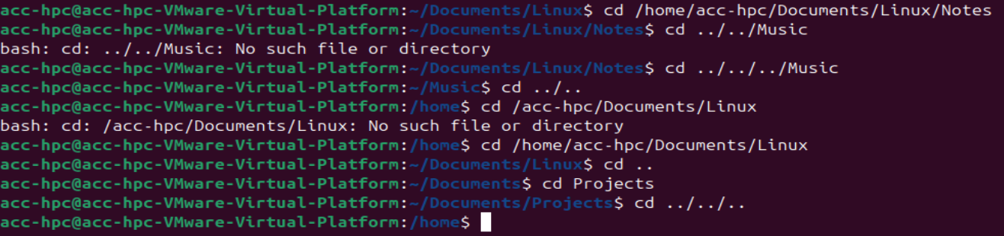

Q11. Find and Display Matching Content Assume you are in: /home/student A file named employees.txt is present in the Documents directory.
Task: 1. Navigate to the Documents directory using a relative path

. 2. Display the contents of employees.txt.
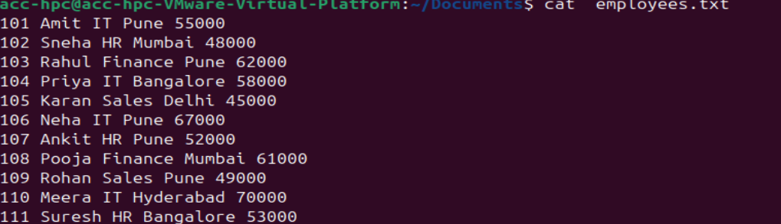

3. Find all employees working in the IT department.
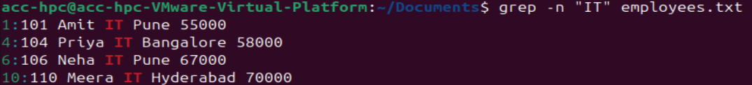

Q12. Environment Variables and Navigation You are currently in: /home/student/Documents/Linux Task
: 1. Display the value of the HOME environment variable
. 2. Navigate to your home directory using the environment variable (not cd ~).
3. List all files, including hidden files, in long listing format.
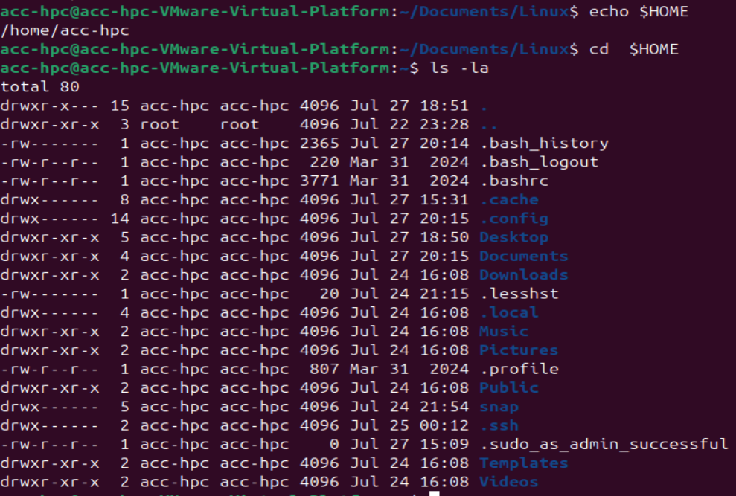

Q13. Search Configuration Files You are in: /home/student A file named config.txt is located in: /home/student/Documents/Linux Task:
1. Display the contents of the Linux directory.
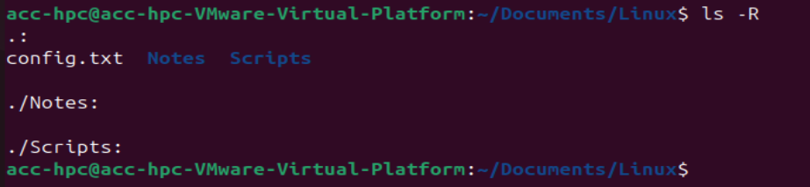

2. Search for the word server inside config.txt.

3. Display line numbers with the matching lines.

Q14. Combine Navigation, Listing, and Searching Current directory: /home/student

Q15. Environment Variables, cat, grep, and ls You are logged in as user student.
Task: 1. Display all environment variables
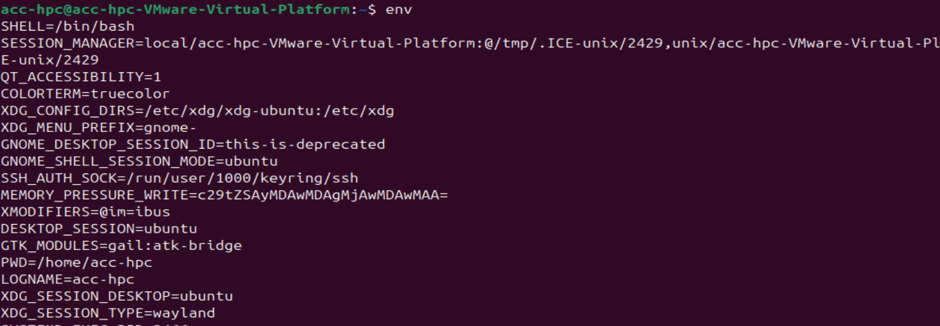

2. Find the environment variable related to the user's home directory.

3. List the contents of your home directory.

4. Display the contents of .bashrc.
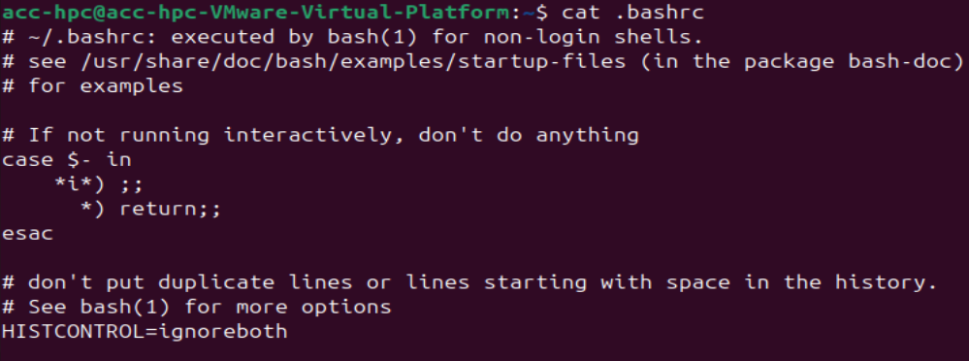

Q16) Print the output of last 9th command executed.
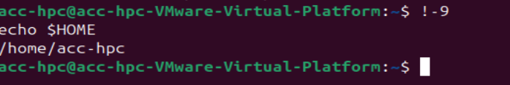

Q17) Print the output of last command executed.


Q18) Write shortnote on SSH service and give examples of the clients used for the SSH service. You should also write configuration for ubuntu machine with command.

